Permanent Magnets for Beamlines and the Recycler Ring at Fermilab
H.D. Glass
Fermi National Accelerator Laboratory [], P.O. Box 500, Batavia, IL 60510 USA

Abstract
Fermilab has nearly completed an upgrade to its accelerator complex which is called the Fermilab Main Injector (FMI). In addition to the FMI ring itself, which is built of standard electromagnets, there are additional components. Two of these components, a beamline used for transporting 8 GeV protons from the existing Booster to the new FMI ring, and a new storage ring for antiprotons, are made using permanent magnets. The storage ring has been named the Recycler because its function is to store leftover p-bars from the previous Tevatron Collider cycle after they have been decelerated to 8 GeV. Both the Recycler and the 8 GeV transfer line use magnets of similar technology. The magnetic material is strontium ferrite, chosen for reasons of economy and high H_{c}. The temperature dependence of the ferrite is compensated by a Ni(30%)Fe(70%) alloy operating near its Curie temperature. Field quality is provided by steel pole pieces and custom shims. The Recycler Ring requires about 360 gradient magnets, 110 quadrupole magnets, and small numbers of Lambertson and special magnets. Nearly all of the magnets have been built. We present details of magnet design, manufacturing, and testing.

1. Permanent Magnet Development
Fermilab carried out a program of research into the development of “hybrid” permanent magnets. The hybrid design uses permanent magnet material to drive the flux, and steel pole pieces are used to determine the field quality. Among the choices for magnetic material, strontium ferrite (Ceramic 8) was chosen because of low cost, stability over time and stability against thermal and radiation effects []. The material is readily available from vendors supplying the automotive and other industries.
1.1. Ferrite Stability
One concern was that magnets built using ferrite should have stable magnetization over the lifetime of the machine (10-30 yr). To test this, a set of 10 test magnets were built and monitored over an extended period. Results were consistent with a model showing that the magnetization decays logarithmically with time. A typical test magnet had a decay constant of –(1.95±0.13) x 10⁻⁴ per log cycle, where the age was measured in days []. Data on a more recently built Recycler gradient magnet show a decay constant of –(3.7±0.9) x 10⁻⁴. This would correspond to a first year loss of about 0.1%, and a total of 0.2% loss over a 10 year lifetime, which is within our ability to tune the machine energy by moving the gradient magnets [].
Another concern was irreversible damage due to thermal excursions. Positive temperature excursions to ≥40ºC are observed to be reversible [Error: Reference source not found], while negative excursions will cause some magnetization loss, at least initially. Cooling a ferrite magnet to 0ºC typically causes a one-time loss of about 0.1%, while subsequent cooling cycles have no effect. To protect against accidental demagnetization in the Fermilab environment, all magnets are cooled to 0ºC in a custom refrigerator prior to final testing.
1.2. Temperature Compensation
A property of ferrite that must be taken into account is that its magnetization has a temperature dependence, dB_{r}/dT = -0.2 %/ºC. Temperature control of each magnet in the Recycler would be impractical; however, an alternative approach was used. This technique [] uses a 30%Ni-70%Fe alloy interspersed among the ferrite bricks as a flux shunt. This alloy has a low Curie temperature (~55 ºC) and its permeability is a nearly linear decreasing temperature dependence. By adjusting the ratio of compensator alloy to ferrite, a temperature independent field in the magnet aperture is achieved.

2. Magnets for the 8 GeV Transfer Line
A part of the overall Main Injector project was a new beamline to transport 8 GeV protons from the existing Booster to the new Main Injector. We chose to make this transfer line out of permanent magnets in order to gain experience in using permanent magnet technology with the eventual goal of applying this experience to the Recycler Ring []. Field quality requirements were less severe, and this turned out to be a useful and significant step up the permanent magnet learning curve. Three major types of magnets were required: a) dipoles of length 2.46 m with integrated fields of 0.57 T-m (45 needed); b) combined function (gradient) magnets with the same integrated field as the dipoles, but length 4.0 m, and with an integrated gradient of 1.85 T (65 needed); and c) pure quadrupoles, 0.5 m long, with gradient 1.48 T (9 needed). Details of the design and performance of these magnets have been presented elsewhere [, , ].
For both the gradient and dipole magnets, bricks were stacked behind the pole pieces on the top and bottom, and in order to achieve a reasonably high field in a small volume, bricks were also stacked along the sides. The dipoles, which used 2 layers of bricks on the top, bottom, and sides, attained fields of 0.23 T. The field quality was, however, sensitive to the location of the side bricks, which were not completely hidden behind the poles. We therefore chose not to use side bricks in the Recycler magnet design.
Commissioning of the 8 GeV line occurred in 1997, and beam transmission is currently > 99% [Error: Reference source not found]. No realignment of magnets has been necessary, and magnet stability and reliability has been excellent.

3. Recycler Magnets
In Table I are listed the types of permanent magnets that are needed, along with the number required in the ring itself, in associated beamlines, and spares. Most of these magnets are now built and are in the process of installation. The large quadrupoles and the mirror magnets are the last magnets to be built for this phase of the project and are being constructed now. Small quadrupoles to be mounted on rotating stands for use in a phase trombone for tune adjustment are to be built later.

magnet | # in ring | # in beam-lines | # spares | status
gradients
RGF | 108 | 2 | 3 | complete
RGD | 106 | 3 | 2 | complete
SGF | 64 | 7 | 4 | complete
SGD | 64 | 8 | 1 | complete
quadrupoles
50.8 cm  (initial phase) | 90 | 9 | 0 | complete
101.6 cm | 10 | 0 | 2 | in assembly
50.8 cm  (upgrade) | 32 | 0 | 0 | to do later
other:
mirror magnets | 2 | 6 | 4 | in assembly
Lambertsons | 0 | 5 | 0 | complete
Table I. List of permanent magnets needed for Recycler.

3.1 Gradients
Unlike the 8 GeV line, which only required one style of gradient magnet, 4 distinct styles were needed for the Recycler. Two of them (RGF, RGD) are used in the normal arc cells; the pole tips, besides being shaped to provide the gradient, also provide sextupole for chromaticity correction. The other two styles (SGF, SGD) are used in the dispersion suppression cells. They are 2/3 the length of the arc gradients, have stronger gradients, and no sextupole. Table II provides a summary of the specifications.

magnet | pole length (m) | BL (T-m) | gradient, b2 (units @ 2.54 cm) | sextupole, b3 (units)
arc focussing (RGF) | 4.4958 | 0.61824 | 619.74 | 8.7
arc defocussing (RGD) | 4.4958 | 0.61824 | -598.08 | -15.1
dispersion suppression, focussing (SGF) | 3.0988 | 0.41216 | 1275.96 | 0.0
dispersion suppression, defocussing (SGD) | 3.0988 | 0.41216 | -1303.08 | 0.0
Table II. Recycler Ring gradient magnet specifications.

These magnets employ a hybrid design similar to that used for the 8 GeV gradients, with some modifications: see Figure 1. Two layers of bricks were used on top and bottom, and no side bricks. The pole pieces also differed in the choice of manufacturing technology. In the 8 GeV line, the poles were form ground, but this was expensive and was not projected to provide a high enough production rate. For the RGDs and RGFs, the poles were made by extrusion followed by two cold-draw passes through precision carbide dies [Error: Reference source not found]. We achieved a high production rate at moderate cost with this technique. For the dispersion suppressor gradients, we chose to use laminated poles because of the difficulty of producing a cold-draw die of the required cross section. The laminated poles required the use of a steel backing plate to transmit the magnetic flux longitudinally.
Measurements were an integral part of the assembly / trimming process. Strength was initially measured with a flipcoil. The magnet was then frozen and measured cold and again after warmup back to room temperature to get the temperature compensation, which was adjusted as needed. The longitudinal field distribution was measured by a Hall probe scanner, from which the bend center was determined. Finally, a rotating Morgan coil was used for harmonics measurement and trimming.
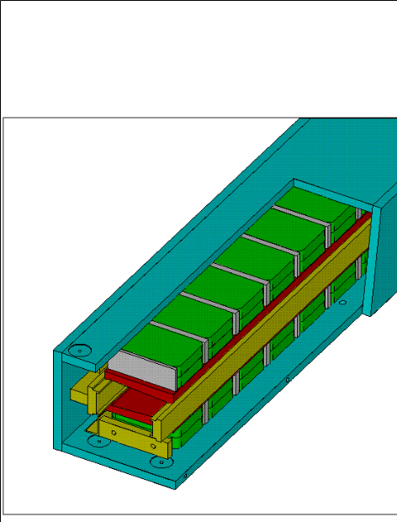
Figure 1. Isometric view of a Recycler gradient magnet.
Tolerances for systematic and magnet-to-magnet (random) errors in the multipoles and strengths were specified in []. Allowed strength variation was 5 units systematic and also 5 units random. Each magnet was trimmed by adding/subtracting whole or fractional bricks until the strength was within 5 units of nominal. Trimming of the multipoles to decapole was accomplished by cutting a custom pair of shims that were attached to the end of the poles. The magnet was measured with a rotating coil, and the data were used to prescribe a tool path for a milling machine to cut a shim of the required shape [].

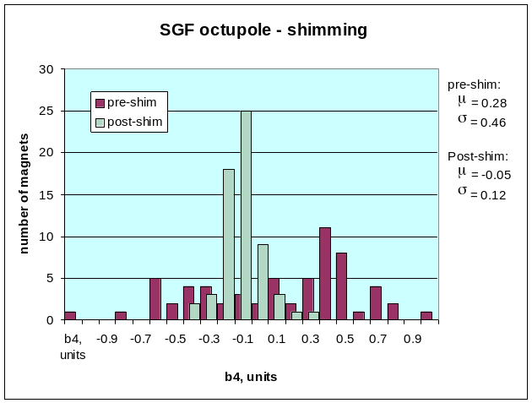
Figure 2. Histogram of measured b4 (normal octupole) before and after shims were installed to the magnet end.
An example of the correction achieved by shimming is shown in Figure 2, which histograms the normal octupole (b4) before and after shimming. The pre-shim standard deviation was σ = 0.46 units, and was narrowed after shimming to 0.12 units. The mean of the distribution was also decreased, from 0.28 units to -0.05 units afterwards.
Measurement results for RGFs are summarized in Table III. Results for the other gradient series were similar. Excellent field quality and temperature compensation were achieved. Measurements of all Recycler magnets are maintained in spreadsheets accessible over the web [].
 | Ideal | mean | std dev
(dB/B)/dT | 0.0 | 0.09 | 0.31
ΔB/B | 0.0 | -0.04 | 3.89
b2 | 619.7 | 619.74 | 0.62
a2 | 0.0 | 0.31 | 0.78
b3 | 8.7 | 8.61 | 0.27
a3 | 0.0 | -0.04 | 0.38
b4 | 0.0 | 0.09 | 0.24
a4 | 0.0 | 0.14 | 0.30
b5 | 0.0 | 0.02 | 0.23
a5 | 0.0 | 0.07 | 0.25
b6 | 0.0 | -0.24 | 0.28
a6 | 0.0 | -0.11 | 0.20
Table III. Comparison of desired values of temperature compensation, strength deviation from nominal, and harmonics with measured quantities for the RGF series.

Gradient production began in November, 1997, and was completed in July, 1998. An average rate of 40 magnets/month (2 per day) was sustained over the course of production, and a peak of 3.6 magnets/day was achieved. Figure 3 shows a stack of completed magnets.
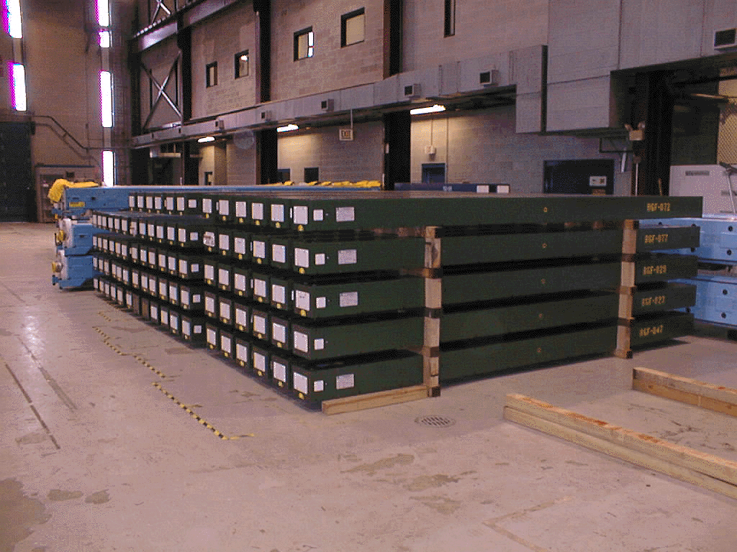Figure 3. A stack of completed gradient magnets in the staging area awaiting installation in the Recycler.

3.2 Quadrupoles
The 8 GeV quadrupole design was sufficiently versatile to be used with only minor modification for the Recycler. The basic pole subassembly with flux return frame was used, but in two varieties that differed by overall length and pole aperture. Within each major variety, differences among magnet types were achieved by modifying the total amount of brick and compensator used. Focusing or defocussing is achieved by a rotation of 90º about the magnet axis. Magnets of a given series are all either focussing or defocusing, as shown in Table IV. Details of quadrupole production are given in [].

series | number | design gradient  (T) | F/D | aperture, pole radius  (mm) | pole length  (m)
small quads
RQAA | 1 | 0.50895 | F | 41.73 | 0.508
RQAB | 1 | 0.91262 | F | 41.73 | 0.508
RQAC | 2 | -1.07770 | D | 41.73 | 0.508
RQMD | 25 | -1.28618 | D | 41.73 | 0.508
RQME | 8 | -1.11610 | D | 41.73 | 0.508
RQMF | 22 | 1.33453 | F | 41.73 | 0.508
RQSA | 2 | -0.44421 | D | 41.73 | 0.508
RQSB | 2 | -0.32594 | D | 41.73 | 0.508
RQSC | 2 | 0.54029 | F | 41.73 | 0.508
RQSD | 2 | -0.36430 | D | 41.73 | 0.508
RQTD | 16 | -0.85698 | D | 41.73 | 0.508
RQTF | 16 | 0.84745 | F | 41.73 | 0.508
 | 99
big quads:
RQEB | 5 | 1.87589 | F | 58.42 | 1.016
RQEC | 5 | -2.23971 | D | 58.42 | 1.016
RQED | 2 | 1.69712 | F | 58.42 | 1.016
 | 12
upgrade quads (rotatable stands)
RQRA | 32 | 1.41170 | F | 41.73 | 0.508
Table IV. Specifications of Recycler quadrupole magnets

Tuning of the magnet strength and harmonics was done using steel rings, or washers. These washers were mounted on threaded rods located behind the poles in each of the four corners of the magnet, so that each pole could have its magnetic potential independently tuned. The magnet was deliberately built a few percent above nominal strength, because adding washers could only be used to decrease the strength. Washers could adjust b3, a3, and a4 in either direction, according to washer distribution. Harmonics b4 and b6 were adjusted via washers in the pole piece ends. A summary of magnet measurements after tuning is shown in Table V.

Small Quadrupoles: Field Quality Results
component | specification |  | measurement
 | systematic | random | systematic |  | random
Δg/g | 5.0 | 8.0 | -0.82 |  | 2.54
b3 | 0.5 | 1.5 | 0.05 |  | 0.62
a3 | - | 1.5 | -0.01 |  | 0.42
b4 | 0.5 | 1.5 | -0.02 |  | 0.46
a4 | - | 1.5 | -0.01 |  | 0.07
b5 | 0.5 | 1.5 | -0.01 |  | 0.43
a5 | - | 1.5 | 0.10 |  | 0.49
b6 | 0.5 | 1.5 | -0.33 |  | 0.31
a6 | - | 1.5 | 0.02 |  | 0.21
temp. compensation |  |  | 0.5 |  | 0.01 | 0.41
Table V. Measurement summary for the Recycler small quadrupoles. All data are expressed in units (1e-4) at 2.54 cm radius.

3.3 Lambertsons and Mirror Magnets
A Lambertson magnet is needed at each end of the two transfer lines leading between the Recycler and Main Injector, and another one is needed at the entrance of the abort line. The magnet consists of a bending region surrounded by bricks on 3 sides; mounted on the fourth side is a solid steel baseplate with a bored hole for the field free region []. The field from the bricks can either point inward or outward, depending on whether upward or downward vertical bending is needed; also, the mounting of the bend region assembly on the baseplate can be done in two ways, resulting in 4 total Lambertson magnet configurations.
Near the intersection of the beamlines and the ring, space constraints prevent the use of standard gradient magnets where a pair are needed. A mirror magnet places all of the ferrite bricks on one side of the aperture, with a thin mirror plate on the other side to complete the flux path []. A diagram of a pair of mirror magnets is shown in Figure 4. Three styles of mirror magnet are needed:
a) MGD, which has the same magnetic field as the RGD, b) MGS, a magnetic clone of the SGF, and c) MDA, which is a pure dipole.
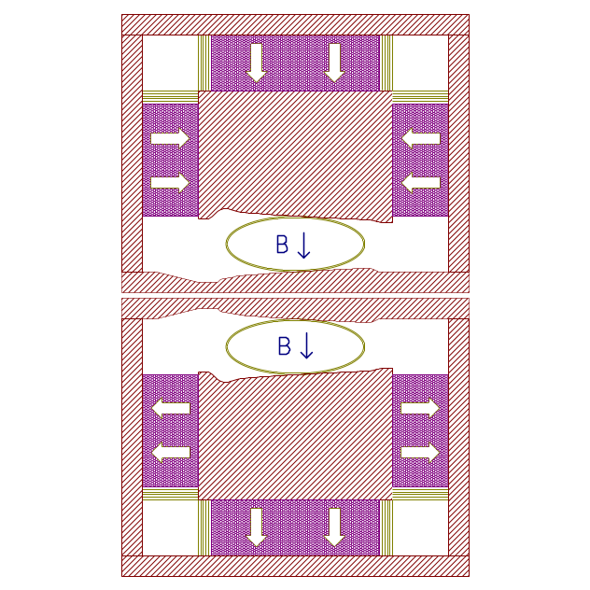
Figure 4. A pair of MGD Mirror magnets configured so the beam in each pipe sees the same bend & focussing field, while allowing a center-to-center beam spacing as small as 8.9 cm. The polarization of the permanent magnet ferrite is opposite for the two magnets.

4. Summary
All magnets for the Recycler Ring (including the RQRA quadrupoles) should be complete and installed by the end of November, 1998. Looking beyond the Recycler, we will build a set of quadrupoles (essentially RQTFs) for Mini-BooNE, a neutrino oscillation experiment at Fermilab. Summing up our experience over the last few years, we have shown that permanent magnets are a useful, economical option for low-field, fixed beam energy applications.

References

. Operated by Universities Research Association, Inc., under Contract # DE-AC02-76CH03000 with the United States Department of Energy.
. G.P. Jackson, ed., Fermilab Recycler Ring Technical Design Report, TM-1991, Nov. 1996.
. H.D. Glass et al., “Stability Tests of Permanent Magnets Built With Strontium Ferrite,” in Proceedings of the 1997 Particle Accelerator Conference (PAC97), Vancouver, Canada, 1997.
. G.W. Foster, “Experience With Permanent Magnets in the Fermilab 8 GeV Line and Recycler Ring,” Proceedings of the 6th European Particle Accelerator Conference, Stockholm, Sweden, June 22-26, 1998.
. K. Bertsche et al., “Temperature Considerations in the Design of a Permanent Magnet Storage Ring,” PAC95.
. S.D. Holmes, “Status of the Fermilab Main Injector and Recycler,” Proceedings of the 1997 Particle Accelerator Conference, Vancouver, Canada, May 12-16, 1997.
. H.D. Glass et al., “Permanent Gradient Magnets for the 8 GeV Transfer Line at FNAL,” Proceedings of PAC’97, Vancouver, Canada, 1997.
. H.D. Glass et al., “Permanent Dipole Magnets for the 8 GeV Transfer Line at FNAL,” Proceedings of PAC’97, Vancouver, Canada, 1997.
. S.M. Pruss et al., “Hybrid Permanent Quadrupoles for the 8 GeV Transfer Line at Fermilab,” Proceedings of PAC’97, Vancouver, Canada, 1997.
. S.D. Holmes et al., “Magnetic Field Quality Specification for Recycler Ring Combined Function and Quadrupole Magnets,” Fermilab Main Injector note MI-0170, 1997.
. B.C. Brown et al., “Hybrid Permanent Magnet Gradient Dipoles for the Recycler Ring at Fermilab,” Proceedings of the 15th International Conference on Magnet Technology, Beijing, China, Oct. 20-24, 1997.
. URL address: http://volk-power-pc.fnal.gov/
. B.C. Brown et al., “Hybrid Permanent Magnet Quadrupoles for the Recycler Ring at Fermilab,” Proceedings of the 15th International Conference on Magnet Technology, Beijing, China, Oct. 20-24, 1997.
. M.P. May et al., “The Design and Construction of the Permanent Magnet Lambertson for the Recycler Ring at Fermilab,” Proceedings of PAC’97, Vancouver, Canada, 1997.
. G.W. Foster, “Mirror Magnet Designs for the Recycler Ring,” Fermilab note MI-0212, Aug 1998.

